Step 1: Create tblProgramOptions to hold your global variable values.
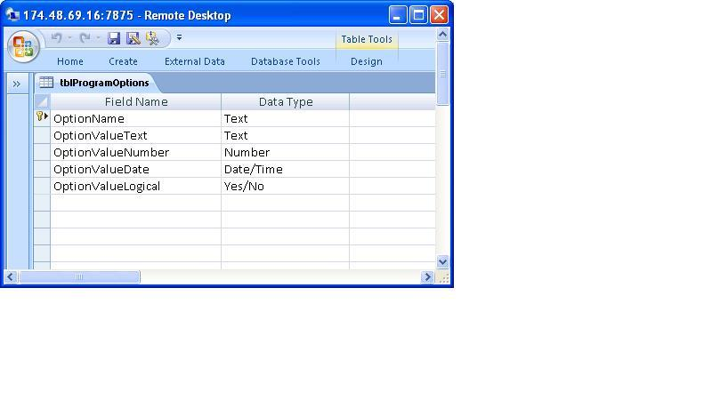
Step 2: Create module level Enum
In a stand alone module, insert the following code at the top before your first procedure::
Enum ProgramOptions
strText = 1
lngNumber = 2
dteDate = 3
logLogical = 4
End Enum
Step 3: Add the following three methods to the module:
Note: If you don’t wrap this line of code then you don’t need the line continuation character, “_”, used below.
Public Function ReadGV(strVariableName As String, strVariableType As _
ProgramOptions) As Variant
Dim rst As ADODB.Recordset
Set rst = New ADODB.Recordset
With rst
.CursorType = adOpenStatic
.ActiveConnection = CurrentProject.Connection
.LockType = adLockReadOnly
.CursorLocation = adUseClient
.Source = "tblProgramOptions"
.Open
If .State = adStateClosed Then
GoTo ErrorProcessor
End If
.MoveFirst
.Find "[OptionName] = '" & strVariableName & "'"
If .EOF Then
'No match found, return Null
ReadGV = Null
Else
ReadGV = .Fields(strVariableType)
End If
.Close
End With

Set rst = Nothing
Exit Function

ErrorProcessor:
‘Insert your error handling code here
Exit Function
End Function
Public Function WriteGV(strVariableName As String, strVariableType As _
ProgramOptions, varValue As Variant) As Boolean
Dim rst As ADODB.Recordset
Set rst = New ADODB.Recordset
With rst
.CursorType = adOpenKeyset
.ActiveConnection = CurrentProject.Connection
.LockType = adLockOptimistic
.CursorLocation = adUseClient
.Source = "tblProgramOptions"
.Open
If .State = adStateClosed Then
GoTo ErrorProcessor
End If
.MoveFirst
.Find "[OptionName] = '" & strVariableName & "'"
If .EOF Then
'No match found, add new record to table
.AddNew
!OptionName = strVariableName
If Not varValue = "" Then
.Fields(strVariableType) = varValue
End If
.Update
Else
'Match found, update value of variable
If Not varValue = "" Then
.Fields(strVariableType) = varValue
End If
.Update
End If
.Close
End With

Set rst = Nothing
Exit Function

ErrorProcessor:

Exit Function
End Function
Public Function DeleteGV(strVariableName As String) As Boolean
Dim rst As ADODB.Recordset
Set rst = New ADODB.Recordset
With rst
.CursorType = adOpenKeyset
.ActiveConnection = CurrentProject.Connection
.LockType = adLockOptimistic
.CursorLocation = adUseServer
.Source = "tblProgramOptions"
.Open
If .State = adStateClosed Then
GoTo ErrorProcessor
End If
.MoveFirst
.Find "[OptionName] = '" & strVariableName & "'"
If .EOF Then
'No match found, exit
DeleteGV = True
Else
'Match found, delete record
.Delete
DeleteGV = True
End If
.Close
End With

Set rst = Nothing
Exit Function

ErrorProcessor:
DeleteGV = False
Exit Function
End Function

